Singapore Institute of Technology
Information and Communications Technology Cluster

BAC3004 Capstone Project

Capstone Project Proposal

General Capstone Project Information

Project Information:

(Project Title): Avatar-Based Oral Assessment for Paper Understanding

(Organization): Singapore Institute of Technology(SIT)

(Initiation):

☐ Project initiated by industry
☒ Project initiated by student

(Multi-disciplinary):

☐ Project is multi-disciplinary (e.g. ICT and ENG)
☒ Project is single-disciplinary (e.g. ICT only)

Candidate Particulars:

(Name of Candidate): Andrew Yaputra

(Matriculation Number): 2303129

(Programme): Applied Computing with Specialization in fintech

(Project Period): 5/1/2026 to 7/8/2026

Academic Supervisor Details:

(Name): Zhang Zhengchen

(Email Address): zhengchen.zhang@singaporetech.edu.sg

(Contact Number): 83228339

(Designation): Associate Professor

Industry Supervisor Details:

(Name): The industry supervisor’s name

(Email Address): The industry supervisor’s email address

(Contact Number): The industry supervisor’s contact number

(Designation): The industry supervisor’s designation

(Department / Division): The industry supervisor’s department / division

Capstone Project Details

This CP proposal report constitutes 10% of the module grade. This proposal report should not exceed 5pages (not including Section A, E, F) including figures, tables, and reference under Section B-D.

Project Overview:
(Please use a separate sheet if necessary)

This project is to develops an agent-based interactive system designed to assess the students understanding of academic papers through oral communication with a virtual avatar. As Compared to physical written tests, students can demonstrate their own understanding by speaking to an avatar that is similar to a virtual examiner. The system uses an end-to-end workflow: recording speech, transcribing it via ASR, performing agent-based reasoning using the paper's content, and generating an avatar-led response.

Project Objectives:
(Please use a separate sheet if necessary)

- Implement a complete oral assessment workflow: 1. Start, 2. Record, 3. Automatic Speech Recognition (ASR), 4. Reasoning, 5. Avatar Response, 6. Feedback

- Develop a system using pre-designed examiner prompts and configurable avatars.

- Provide automated, rubric-based feedback based on evidence from the session transcript.

Industry Relevancy:
(Please use a separate sheet if necessary)

Enhancement of Academic Integrity and Learning, beyond doing written reports, which are increasingly susceptible to generic AI generation, this project encourages authentic assessment. Students must demonstrate real-time understanding through verbal reasoning, which is an important skill for future researchers and professionals in the ICT and Fintech sectors.
Scalability of Oral Assessments in Higher Education. For universities conducting individual oral examinations it is highly resource-intensive and difficult or impossible for large cohorts. This system allows educational institutions to scale oral comprehension checks, ensuring every student can be assessed on their ability to understand complex paper findings without increasing the administrative load on the school.

Project Scope:
(Please use a separate sheet if necessary)

In-Scope: Paper ingestion (PDF/Text), audio recording/ASR, agent-based dialogue orchestration, avatar speech output, and rubric-based feedback generation.

Out-of-Scope: Custom avatar training, general knowledge questions outside the provided paper, and biometric monitoring

Project Outputs and Deliverables
(Please use a separate sheet if necessary)

- Functional Product: A system supporting end-to-end oral assessment.

- Documentation: Technical specifications of the 6-agent architecture (Session Orchestrator, RAG, Dialogue Manager, etc.).

- Evaluation Report: Results from technical testing and pilot evaluations (consistency checks and student surveys).

Knowledge and Training Requirements

Applicable Knowledge from the Degree Programme
(Please use a separate sheet if necessary)

Machine Learning (INF2008): This module provides the foundational knowledge required to understand and integrate the Large Language Models (LLMs) used for the examiner-style questions and the reasoning logic behind the Rubric Grader Agent.

Software Requirements Engineering and Design (BAC2001): This knowledge is directly applied to creating the project’s functional requirements , designing the Dialogue State Machine , and architecting the multi-agent system.

Additional Knowledge, Skillsets, or Certifications Required
(Please use a separate sheet if necessary)

Speech Processing: Experience with Speech-to-Text (Whisper) and Text-to-Speech integration.
RAG (Retrieval-Augmented Generation): Techniques for segmenting papers into retrievable chunks.
Avatar Integration: Working with external services like HeyGen for video/audio generation

Training Required and Provided
(Please use a separate sheet if necessary)

Please provide details of any additional relevant training that is required by, and that will be provided to the candidate for the purpose of the project

Project Timeline

Phase / Month | Key Activities | Expected Outputs & Deliverables
Phase 0: Scoping (Jan – Feb 2026) | Project selection and requirement finalization | Final Project Proposal; Prompt & Rubric configuration files (markdown/JSON).
Phase 1: Foundation (Mar 2026) | Development of Agent A1 (Ingestion) and Agent A2 (Retrieval) ; setting up the vector database for paper segmentation. | Functional RAG (Retrieval-Augmented Generation) pipeline for PDF/Text extraction.
Phase 2: Voice and Brain (Apr 2026) | Milestone 1: Integration of OpenAI Whisper for ASR and Agent A3 for examiner dialogue logic. | End-to-end flow with text-based examiner reasoning and audio transcription.
Phase 3: Integration (May 2026) | Milestone 2: Connecting the HeyGen API for visual avatar speech output. | Working Student Assessment Page featuring a talking virtual avatar.
Phase 4: Logic/Rubric (Jun 2026) | Milestone 3: Implementing Agent A5 (Rubric Grader) and refining adaptive dialogue state machines. | Automated Feedback Page with evidence-grounded scoring and transcript export.
Phase 5: Evaluation (Jul 2026) | Milestone 4: Conducting classroom pilot trials and consistency checks | Evaluation Report; system performance optimization and bug fixes.
Phase 6: Closure (Aug 2026) | Finalizing documentation; preparing final presentation and handover before 8 August. | Completed Capstone Dissertation; Final Source Code and Session Records.

A detailed visualization of the project’s six-phase lifecycle is provided in Annex A: Project Gantt Chart

Supervisor Remarks
(Additional details relevant to the project; please use a separate sheet if necessary)

Industry Supervisor Remarks

Please provide any other details that are relevant to the project, e.g., references or research papers, description on the complexity of the project, expected learning opportunities, etc.

Academic Supervisor Remarks

Please provide any other details that are relevant to the project, e.g., references or research papers, description on the complexity of the project, expected learning opportunities, etc.
This project is proposed by the Academic Supervisor. The student will gain hands-on experience with multimodal agent systems.

- Declaration of Conformity

Declaration by Industry Supervisor

I hereby acknowledge that I have engaged and discussed with the Candidate on the Capstone Project details above, and we are in agreement on the contents provided in the sections above.

Signature 
Name of Industry Supervisor: The industry supervisor’s name
Designation: The industry supervisor’s designation
Department: The industry supervisor’s department / division
Contact No: The industry supervisor’s contact number
Email: The industry supervisor’s email address
Date: Click or tap to enter a date

Declaration by Candidate

I hereby acknowledge that I have engaged and discussed with my Industry Supervisor on the Capstone Project details above, and we are in agreement on the contents provided in the sections above.

Signature 
Name of Candidate: Andrew Yaputra
Contact No: 91275288
Email: yaputraandrew5288@gmail.com
Date: 24/2/2026

Declaration by Academic Supervisor

I hereby acknowledge that I have read and understood the Capstone Project details above. I believe that the proposed project is appropriate to fulfil the requirements for the BAC3004 Capstone Project module.

Signature 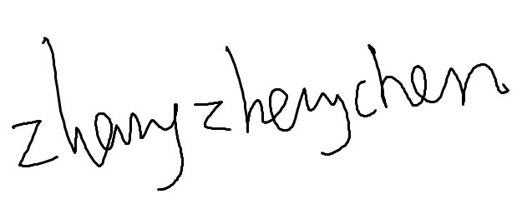
Name of Academic Supervisor: Zhang Zhengchen
Contact No: 83228339
Email: zhengchen.zhang@singaporetech.edu.sg
Date: 27/2/2026

Annex

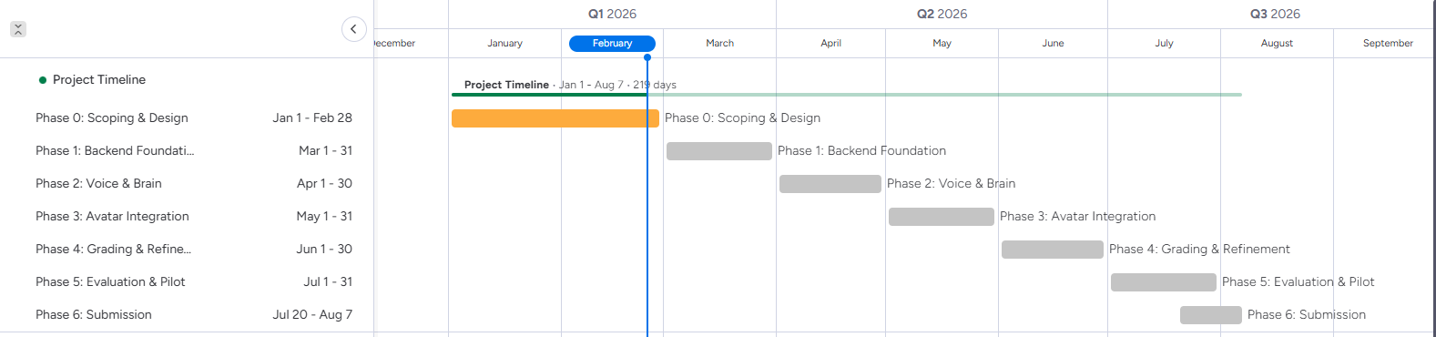
Annex A: Project Gantt Chart

END OF FORM

